Reactions Unit: Sample Test
Name: ______________________________ Pd: ______
You may use the solubility rules and the activity series provided. Part I is worth 1 point per question (20 points). Part II is on the following pages.
Part I: Multiple Choice

1. In the equation 4Fe + 3O₂ → 2Fe₂O₃, what does the subscript 3 in Fe₂O₃ represent?
A. Each formula unit of Fe₂O₃ contains 3 oxygen atoms.
B. 3 molecules of Fe₂O₃ are produced.
C. 3 moles of O₂ react.
D. The charge on the oxygen ion is 3.
2. How many chlorine atoms are on each side of the equation 2Fe + 3Cl₂ → 2FeCl₃?
A. 3 on the left and 3 on the right
B. 6 on the left and 3 on the right
C. 6 on the left and 6 on the right
D. 2 on the left and 6 on the right
3. Which equation is correctly balanced?
A. Mg + O₂ → MgO
B. 2Mg + O₂ → 2MgO
C. Mg + O₂ → MgO₂
D. 2Mg + 2O₂ → 2MgO
4. Which equation correctly shows the balanced decomposition of calcium chloride?
A. CaCl₂ → Ca + 2Cl
B. CaCl → Ca + Cl
C. 2CaCl₂ → 2Ca + Cl₂
D. CaCl₂ → Ca + Cl₂
5. Which equation represents a combustion reaction?
A. 2Na + Cl₂ → 2NaCl
B. C₃H₈ + 5O₂ → 3CO₂ + 4H₂O
C. 2KClO₃ → 2KCl + 3O₂
D. CaO + H₂O → Ca(OH)₂
6. What type of reaction is Mg + 2HCl → MgCl₂ + H₂?
A. Single replacement
B. Synthesis
C. Double replacement
D. Decomposition
7. Which best classifies the reaction H₂SO₄ + 2NaOH → Na₂SO₄ + 2H₂O?
A. Combustion
B. Single replacement
C. Decomposition
D. Neutralization
8. What are the products when water decomposes? H₂O(l) → ?
A. H and O
B. H₂O₂
C. H₂ and O₂
D. H₂ and O
9. What is the product when aluminum reacts with sulfur, Al + S₈?
A. AlS
B. Al₂S₃
C. Al₃S₂
D. Al₂S
10. Which substance must be a reactant in every combustion reaction?
A. CO₂
B. H₂O
C. N₂
D. O₂
11. Using the activity series provided, which reaction will NOT occur?
A. Ag(s) + MgCl₂(aq) →
B. Mg(s) + FeCl₂(aq) →
C. Zn(s) + Pb(NO₃)₂(aq) →
D. Cu(s) + AgNO₃(aq) →
12. Using the activity series provided, which halogen reaction will occur?
A. I₂(s) + NaBr(aq) →
B. Br₂(l) + NaCl(aq) →
C. Cl₂(g) + NaI(aq) →
D. I₂(s) + KCl(aq) →
13. What are the products when solid sodium reacts with liquid water?
A. Na₂O and H₂
B. NaH and O₂
C. NaOH and O₂
D. NaOH and H₂
14. Aqueous Al₂(SO₄)₃ is mixed with aqueous Na₃PO₄. What are the formulas of the products?
A. AlPO₄ and Na₂SO₄
B. Al₃(PO₄)₂ and Na₃SO₄
C. AlPO₄ and Na₃SO₄
D. Al₂PO₄ and NaSO₄
15. Aqueous Pb(NO₃)₂ is mixed with aqueous KI. Using the solubility rules provided, what is the precipitate?
A. KNO₃
B. PbI₂
C. PbI
D. K₂I
16. Using the solubility rules provided, which pair of aqueous solutions will produce NR (no reaction)?
A. NaOH + FeCl₃
B. Na₂S + CuCl₂
C. LiBr + KNO₃
D. NaOH + Ni(NO₃)₂
17. Aqueous K₂CO₃ is mixed with aqueous CaCl₂ and a white precipitate forms. Which is the net ionic equation?
A. Ca²⁺(aq) + CO₃²⁻(aq) → CaCO₃(s)
B. 2K⁺(aq) + 2Cl⁻(aq) → 2KCl(aq)
C. K₂CO₃(aq) + CaCl₂(aq) → CaCO₃(s) + 2KCl(aq)
D. 2K⁺(aq) + CO₃²⁻(aq) + Ca²⁺(aq) + 2Cl⁻(aq) → CaCO₃(s) + 2K⁺(aq) + 2Cl⁻(aq)
18. When writing a total ionic equation for a reaction in water, which species should NOT be written as separate ions?
A. Na₂SO₄(aq)
B. KNO₃(aq)
C. Ba(NO₃)₂(aq)
D. AgCl(s)
19. Hydrogen and oxygen react to form water: 2H₂ + O₂ → 2H₂O. The box below shows the mixture before the reaction. If the reaction goes to completion, how many H₂O molecules form?
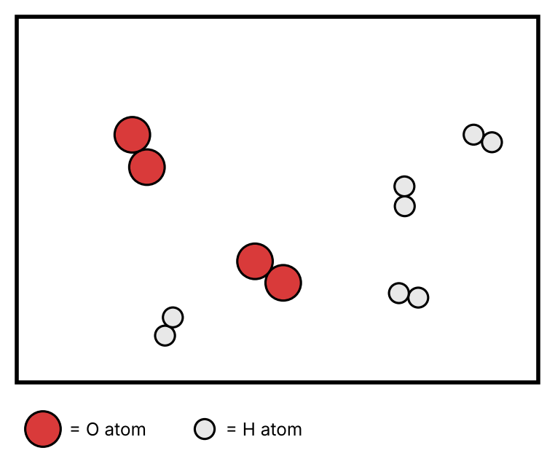
A. 2
B. 4
C. 6
D. 8
20. What is the correct formula for iron(III) sulfate?
A. FeSO₄
B. Fe₃(SO₄)₂
C. Fe₂(SO₄)₃
D. Fe₂SO₄

Part II: Free Response
1) Classify each reaction as Synthesis (S), Decomposition (D), Combustion (C), Single Replacement (SR), Double Replacement (DR), or Neutralization (N), then balance it. (12 pts)
a. ___Mg + ___Fe₂O₃ → ___MgO + ___Fe Type: ________
b. ___Al + ___O₂ → ___Al₂O₃ Type: ________
c. ___C₈H₁₈ + ___O₂ → ___CO₂ + ___H₂O Type: ________
d. ___Fe₂(SO₄)₃ + ___KOH → ___Fe(OH)₃ + ___K₂SO₄ Type: ________
e. ___Al₂O₃ → ___Al + ___O₂ Type: ________
f. ___H₃PO₄ + ___Ca(OH)₂ → ___Ca₃(PO₄)₂ + ___H₂O Type: ________
2) Predict the products and balance each equation. If no reaction occurs, write NR. (16 pts)
a. Ca + Br₂ → __________________________________
b. Cl₂ + MgI₂ → __________________________________
c. Zn + NaCl → __________________________________
d. C₇H₁₆ + O₂ → __________________________________
e. BaCl₂ → __________________________________
f. NaBr(aq) + KNO₃(aq) → __________________________________
g. Mg + Fe(NO₃)₃ → __________________________________
h. Lithium sulfate (aq) reacts with barium chloride (aq).
3) A student plans to decompose calcium bromide, CaBr₂, into its elements. (6 pts)
a. Write the balanced equation for the reaction.
b. Write the electron configuration for calcium. You may use full or noble gas notation.
c. The reaction produces 6.00 g of calcium metal. How many moles of calcium is this? Show your work.
d. Explain why one of the products is written as a diatomic molecule (Br₂) instead of Br.
4) Predict the products, balance the equation, and write the total ionic and net ionic equations. If no reaction occurs, write NR. Record the spectator ions. (12 pts)
a. Na₃PO₄(aq) + CaCl₂(aq)
Balanced:
Total ionic:
Net ionic:
Spectators:
b. Al(s) + Pb(NO₃)₂(aq)
Balanced:
Total ionic:
Net ionic:
Spectators:
c. Aqueous potassium hydroxide is mixed with aqueous copper(II) nitrate.
Balanced:
Total ionic:
Net ionic:
Spectators:

